a) Given that: $x\left(t\right)=e^{-t}\left[u\left(t\right)-u\left(t-2\right)\right]$

$$E_{x}=\int_{-∞}^{+∞}{{\left|x\left(t\right)\right|}^{2}dt}=\int_{0}^{2}{{\left|e^{-t}\right|}^{2}dt}=\frac{1}{2}\left(1-e^{-4}\right)$$

*(Reader sketches the signal by yourself)*

b)

$$P_{x}=\frac{1}{T}\int_{-T/4}^{{3T}/4}{{\left|x\left(t\right)\right|}^{2}dt}=\frac{1}{T}\int_{-T/4}^{T/4}{{\left|A\right|}^{2}dt}=\frac{A^{2}}{2}$$

a) Given that:

1. Check for linearity:

Let:

From and , , the system is nonlinear.

2. Check for time invariant:

Let: $x(t)\underset{→}{S}y=x^{2}(t)$

$→y\left(t-T\right)=x^{2}(t-T)$ $(1)$ (delay the ouput).

Let: $x_{T}\left(t\right)=x\left(t-T\right)\underset{→}{S}y_{T}=x_{T}^{2}\left(t\right)=x^{2}\left(t-T\right) (2)$

Since, $\left(1\right)=(2)$, therefore, the system is time invariant.

b) Given that:

1. Check for linearity:

Let:

From and , , the system is nonlinear.

2. Check for time invariant:

Let: $x\left[n\right]\underset{→}{S}y[n]=2x\left[2n-1\right]+3$

$→y\left[n-N\right]=2x\left[2n-2N-1\right]+3$ $(1)$ (delay the ouput).

Let: $x_{N}[n]=x[n-N]\underset{→}{S}y_{N}=2x_{N}\left[2n-1\right]+3=2x_{N}\left[2n-N-1\right]+3 (2)$

Since, $\left(1\right)≠(2)$, therefore, the system is time variant.

Given that: $y\left[n\right]=4x\left[n\right]-2x\left[n-1\right]+3x\left[n-2\right]$

a)

$$y\left[n\right]=x\left[n\right]*h\left[n\right]=\sum_{k=-∞}^{+∞}{x\left[n-k\right]h\left[k\right]}=\sum_{k=0}^{2}{x\left[n-k\right]h\left[k\right]}$$

$$=x\left[n\right]h\left[0\right]+x\left[n-1\right]h\left[1\right]+x\left[n-2\right]h\left[2\right] (1)$$

$$=4x\left[n\right]-2x\left[n-1\right]+3x\left[n-2\right] (2)$$

Compare $\left(1\right)$ and $\left(2\right)$, we obtain: $h\left[n\right]=\left[4, -2, 3\right]$

b) Given that: $x\left[n\right]=[2, -1, 1, 3, 1]$

$$+ y\left[0\right]=4x\left[0\right]-2x\left[-1\right]+3x\left[-2\right]=4×2-2×0+3×0=8$$

$$+ y\left[1\right]=4x\left[1\right]-2x\left[0\right]+3x\left[-1\right]=4×\left(-1\right)-2×2+3×0=-8$$

$$+ y\left[2\right]=4x\left[2\right]-2x\left[1\right]+3x\left[0\right]=4×1-2×(-1)+3×2=12$$

$$+ y\left[3\right]=4x\left[3\right]-2x\left[2\right]+3x\left[1\right]=4×3-2×1+3×(-1)=7$$

$$+ y\left[4\right]=4x\left[4\right]-2x\left[3\right]+3x\left[2\right]=4×1-2×3+3×1=1$$

$$+ y\left[5\right]=4x\left[5\right]-2x\left[4\right]+3x\left[3\right]=4×0-2×1+3×3=7$$

$$+ y\left[6\right]=4x\left[6\right]-2x\left[5\right]+3x\left[4\right]=4×0-2×0+3×1=3$$

Therefore, $y\left[n\right]=\left[8, -8, 12, 7, 1, 7, 3\right]$

Given that: $h\left(t\right)=2e^{-2t}u\left(t\right), x\left(t\right)=u\left(t+2\right)-u\left(t-2\right)$

a)

For $t<-2$:

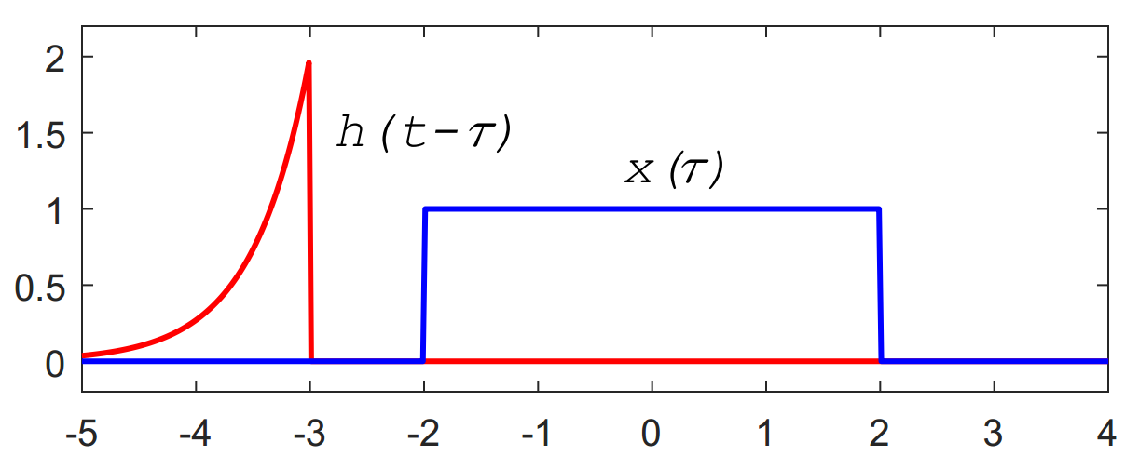

For $-2≤t<2$:

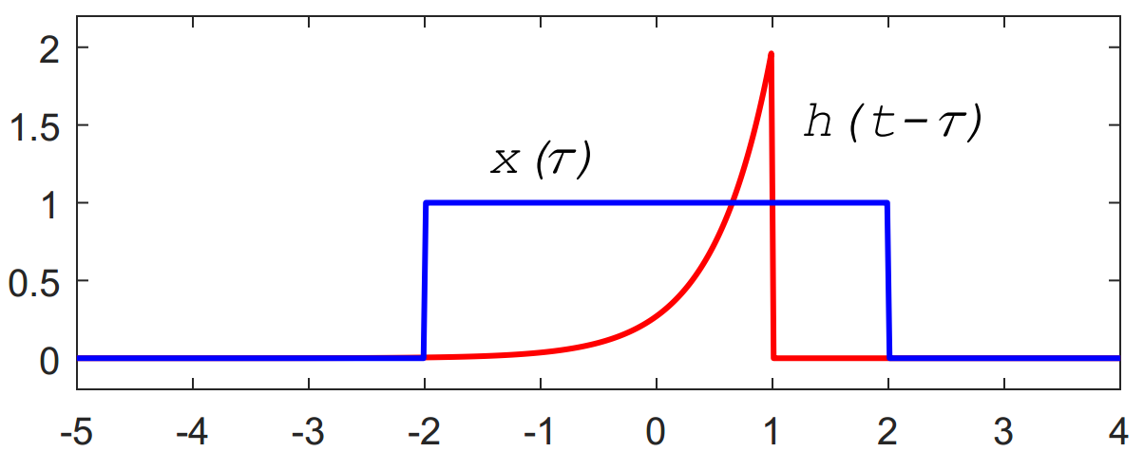

For $t≥2$:

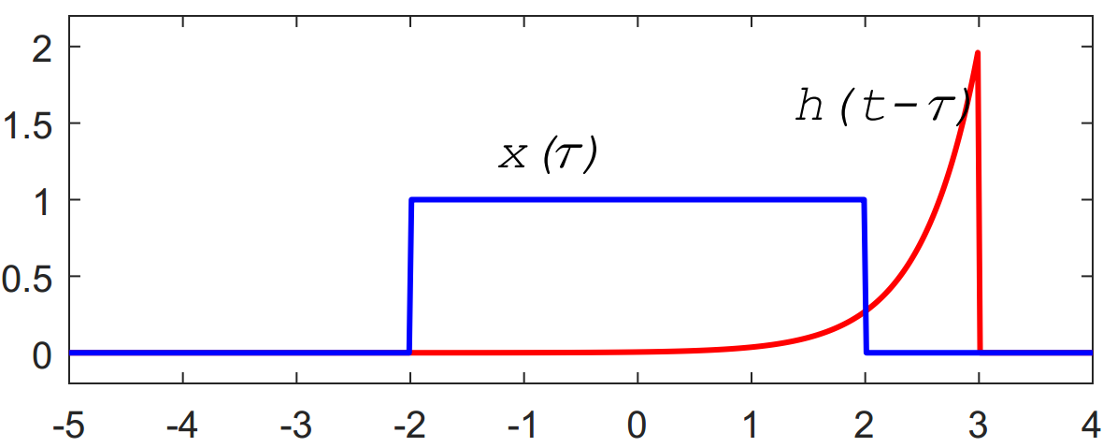

b)

For $t≤-2$, $x\left(τ\right)$ and $h(t-τ)$ does not overlap, therefore $y\left(t\right)=0$.

For $-2≤t<2$:

$$y\left(t\right)=\int_{-∞}^{+∞}{x\left(τ\right)h\left(t-τ\right)dτ}=\int_{-2}^{t}{1.e^{-2\left(t-τ\right)}dτ}=e^{-2t}\int_{-2}^{t}{e^{2τ}dτ}=\frac{1}{2}e^{-2t}\left(e^{2t}-e^{-4}\right)$$

For $t≥2$:

$$y\left(t\right)=\int_{-∞}^{+∞}{x\left(τ\right)h\left(t-τ\right)dτ}=\int_{-2}^{2}{1.e^{-2\left(t-τ\right)}dτ}=e^{-2t}\int_{-2}^{2}{e^{2τ}dτ}=\frac{1}{2}e^{-2t}\left(e^{4}-e^{-4}\right)$$

Thus,

$$y\left(t\right)=\left\{\begin{aligned}0 , t≤-2 \\ \frac{1}{2}e^{-2t}\left(e^{2t}-e^{-4}\right), -2<t<2 \\ \frac{1}{2}e^{-2t}\left(e^{4}-e^{-4}\right), t≥2\end{aligned}\right.$$